Exhibit 1. F Worksheet in Alphabetical Testing Loop

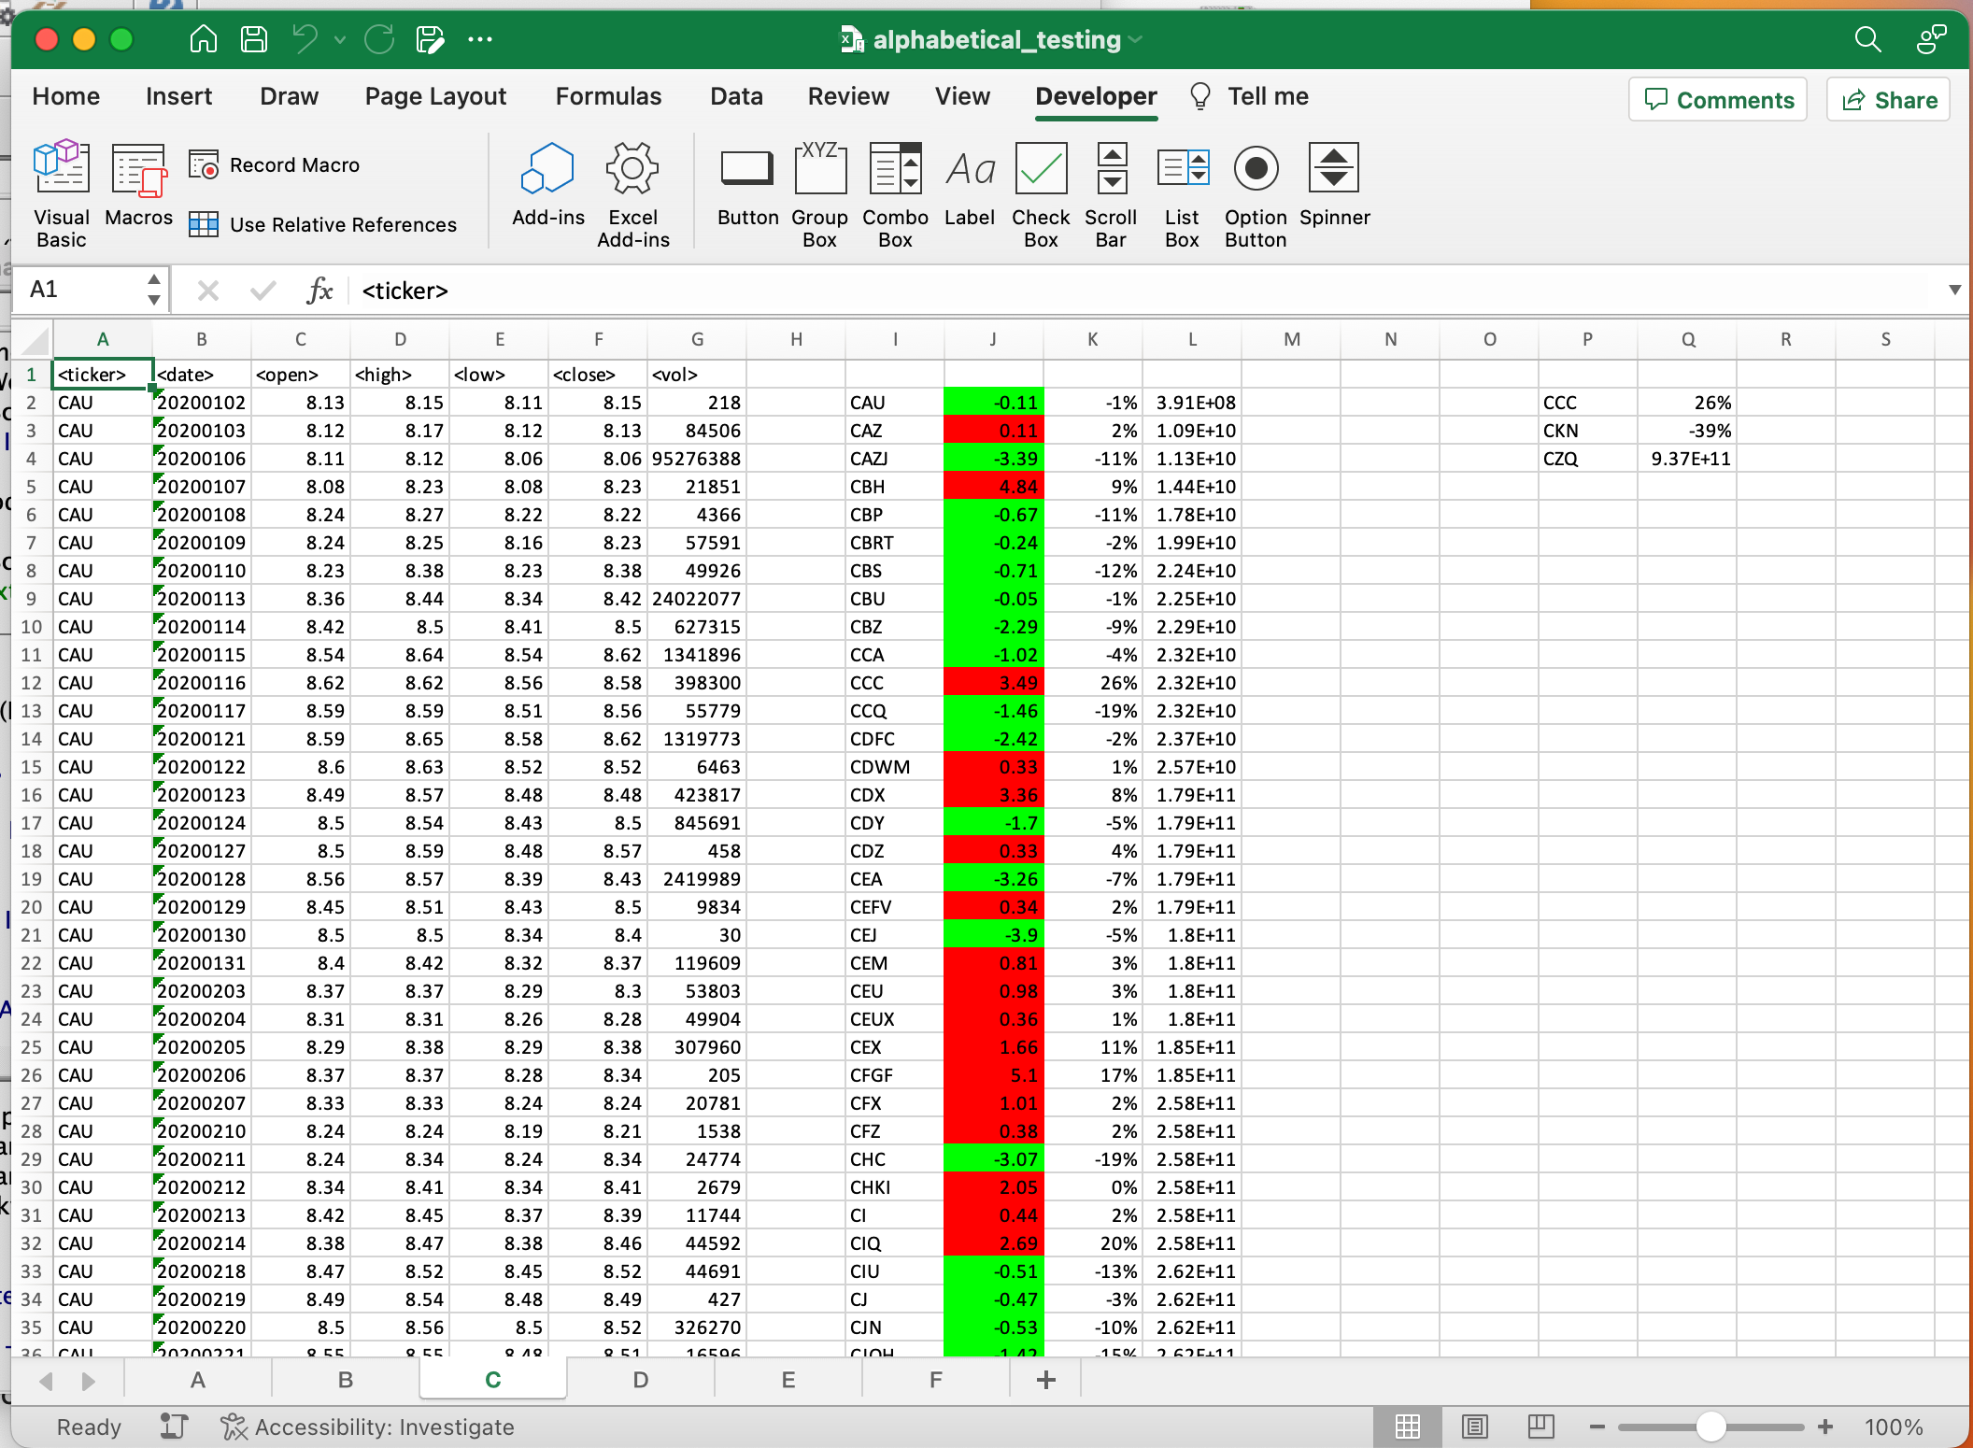

Exhibit 2. C Work Sheet in Alphabetical Testing Loop

Exhibit 3. Sheet 2018 Multiple Year Stock Data

Exhibit 4. Sheet 2019 Multiple Year Stock Data

Exhibit 5. Sheet 2020 Multiple Year Stock Data